**DATABASE MANAGEMENT SYSTEM**

**MINGGU 6 - PERINTAH DML (DATA MANIPULATION LANGUAGE)-SELECT**

NAMA : ISEP LUTPI NUR

NPM : 2113191079

NO ABSEN : 12

KELAS : A2

# **6-6 : Retrieving Data Practice Solutions**

## Exercise 1: Retrieving Columns from tables

1. Write a simple query to view the data inserted in the tables created for the academic database
   1. Table AD_ACADEMIC_SESSIONS

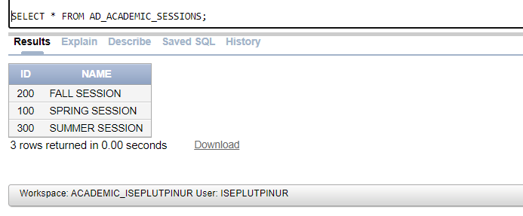

* 1. Table AD_COURSES

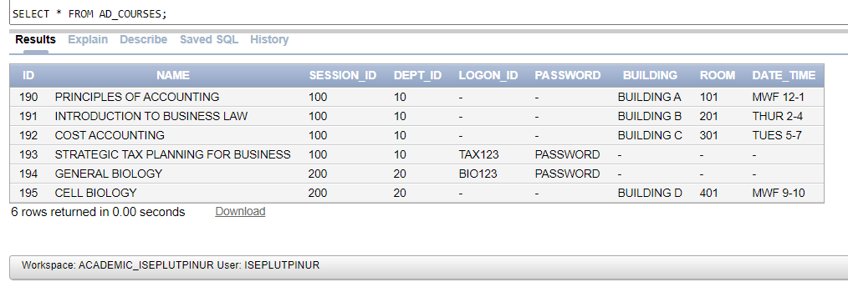

* 1. Table AD_DEPARTMENTS

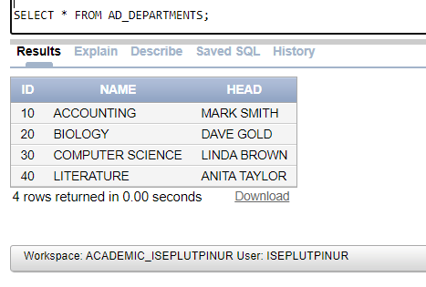

* 1. Table AD_EXAMS

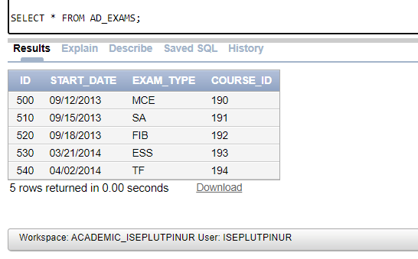

* 1. Table AD_EXAM_RESULTS

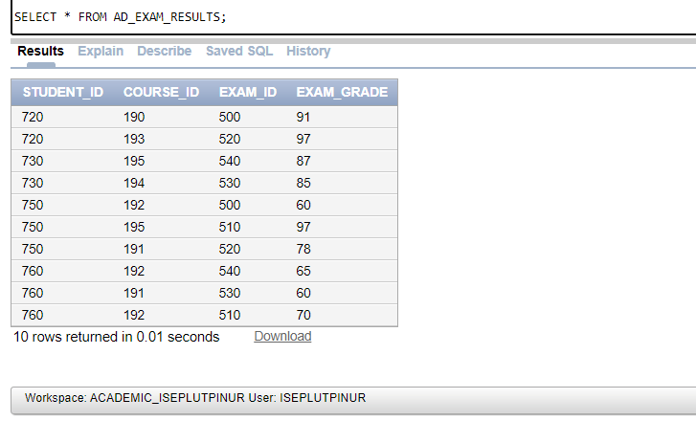

* 1. Table AD_EXAM_TYPES

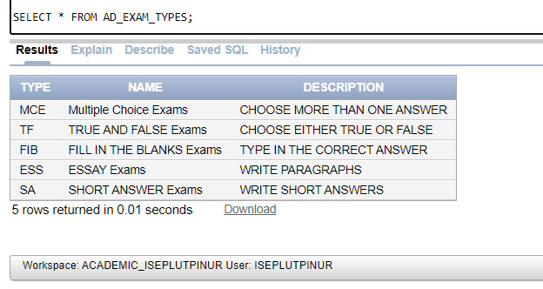

* 1. Table AD_FACULTY_COURSE_DETAILS

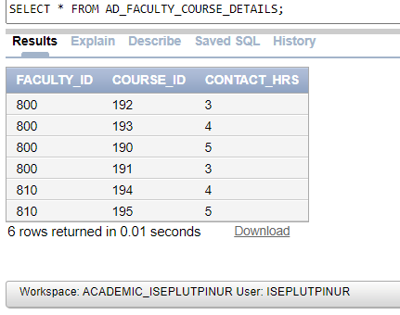

* 1. Table AD_PARENT_INFORMATION

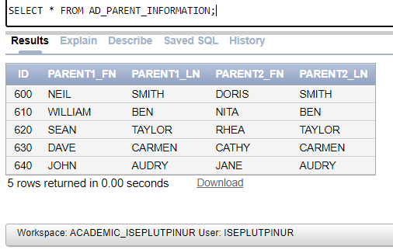

* 1. Table AD_STUDENTS

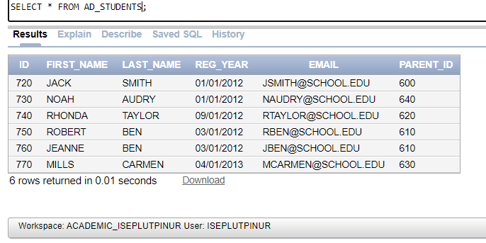

* 1. Table AD_FACULTY

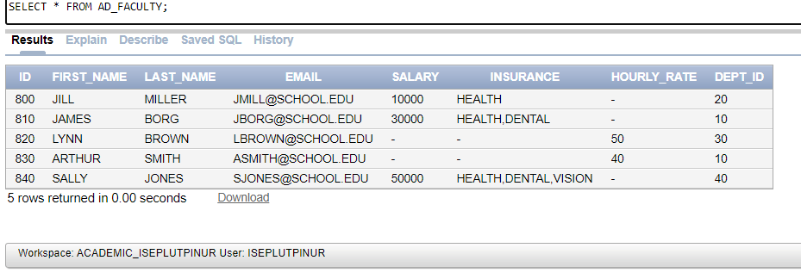

* 1. Table AD_STUDENT_ATTENDANCE

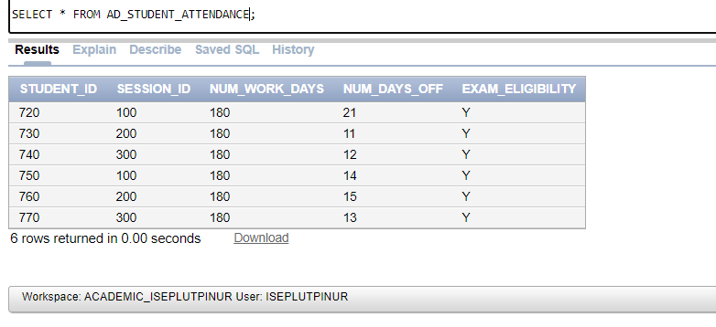

* 1. Table AD_FACULTY_LOGIN_DETAILS

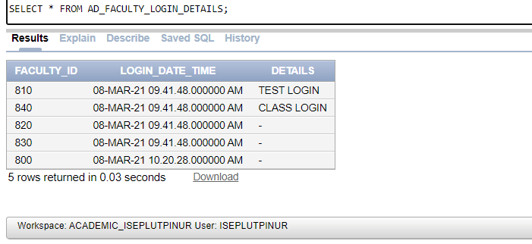

* 1. Table AD_STUDENT_COURSE_DETAILS

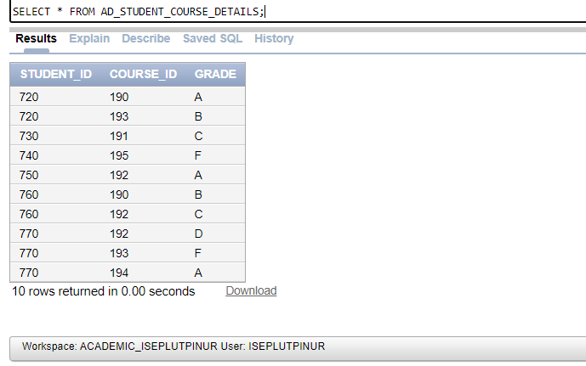

1. Write a query to retrieve the exam grade obtained by each student for every exam attempted.

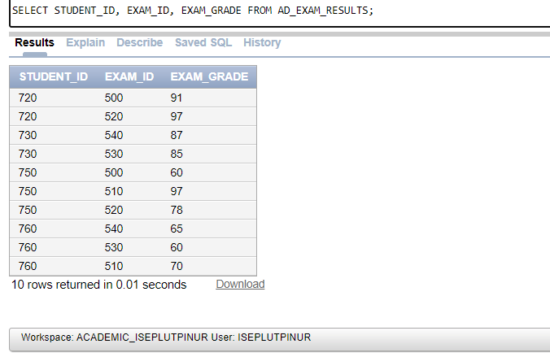

1. Write a query to check if a student is eligible to take exams based on the number of days he/she attended classes.

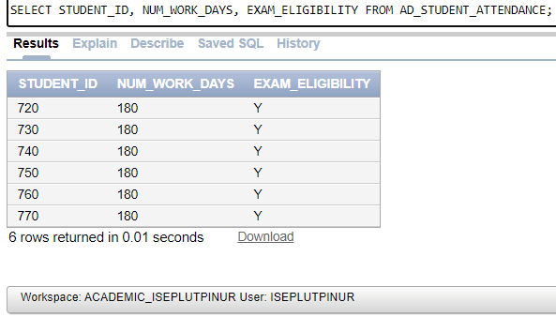

1. Display the LOGIN_DATE_TIME for each faculty member

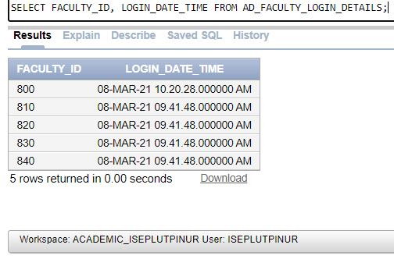

1. Display the name of the Head of the Department for each of the Departments.

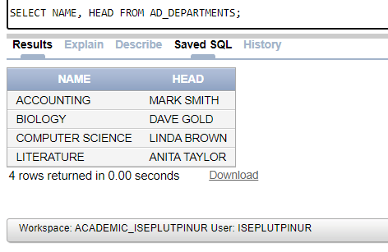

1. Retrieve the student ID and first name for each student concatenated with literal text to look like this: 720: FIRST NAME IS JACK

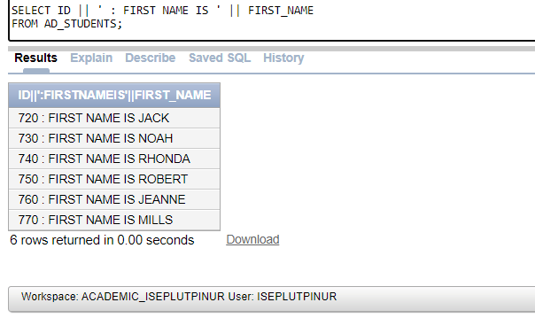

1. Display all the distinct exam types from the AD_EXAMS table.

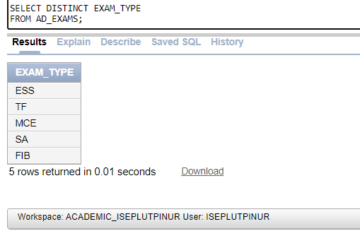

## Exercise 2: Using Arithmetic Operators and Column Alias in SELECT statements

1. The faculty of the different Departments realized that the exam grades entered in the AD_EXAM_RESULTS were showing an increased value of 5 points for each entry. Can you display the exam grades with 5 points subtracted from the marks obtained by each student?

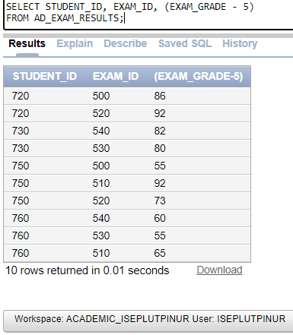

1. Display the percentage of days students have taken off and their eligibility for taking the exams.

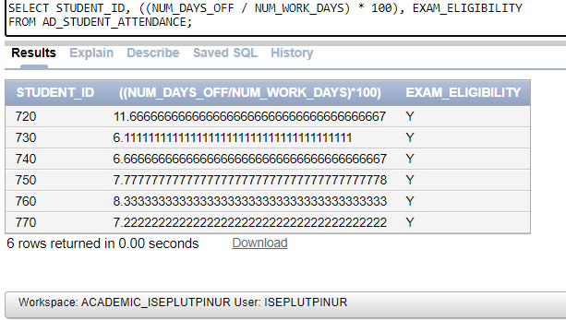

1. Display the FIRST_NAME and EMAIL for each student like this:

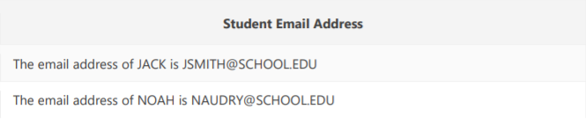

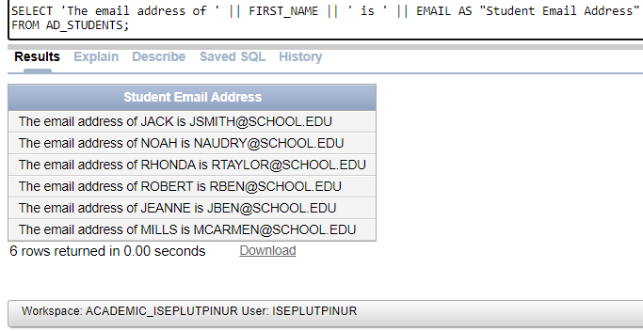

1. Display the department name and the head of the department from the AD_DEPARTMENTS table like this:

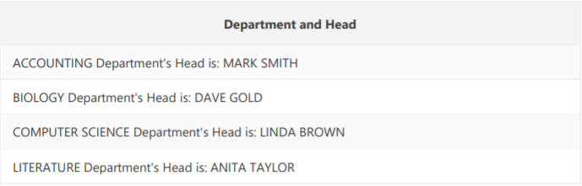

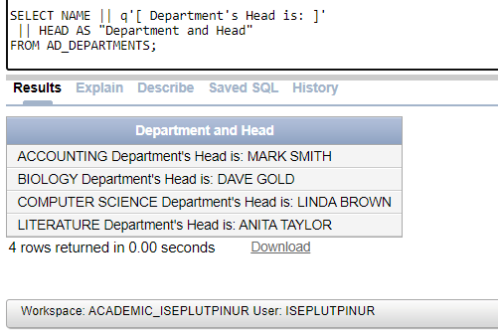

1. Display the distinct DEPARTMENT_ID from the AD_COURSE_DETAILS table.

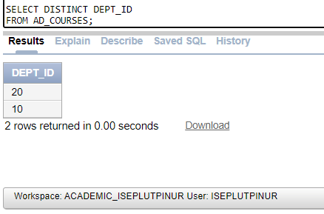

# **6-7 : Restricting Data Using WHERE Statement Practice Solutions**

## Exercise 1: Restricting Data Using SELECT

1. Display the course details for the Spring Session.

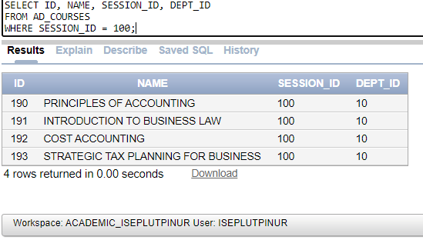

1. Display the details of the students who have scored more than 95.

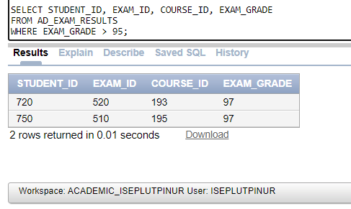

1. Display the details of the students who have scored between 65 and 70

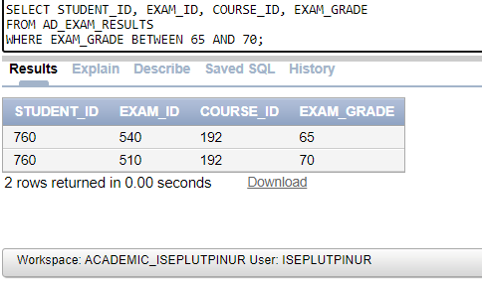

1. Display the students who registered after 01-Jun-2012

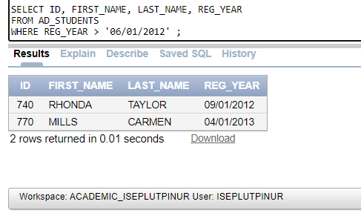

1. Display the course details for departments 10 and 30.

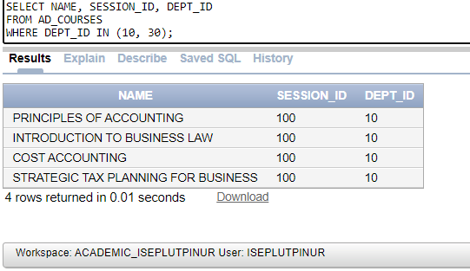

1. Display the details of students whose first name begins with the letter "J".

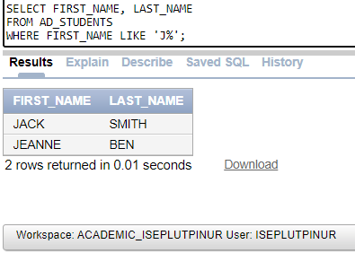

1. Display the details of students who have opted for courses 190 or 193.

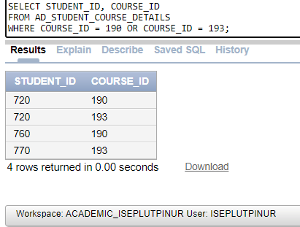

1. Display the course details offered by department 30 for the Fall Session (Session ID 200)

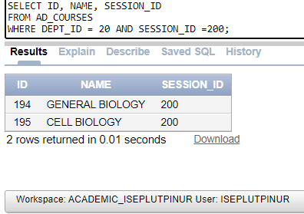

1. Display the course details of courses not being offered in the summer and fall session (Session ID 200 and 300)

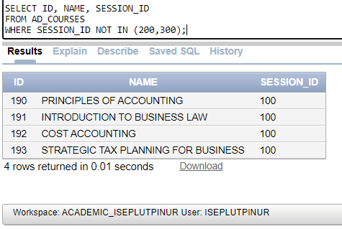

1. Display the course details for department 20.

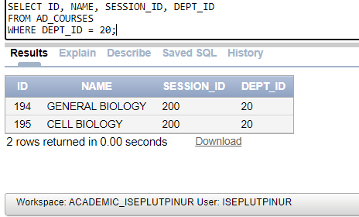

# **6-8 : Sorting Data Using ORDER BY Practice Solutions**

## Exercise 1: Sorting Data Using ORDER BY

1. Display all fields for each of the records in ascending order for the following tables:
2. AD_STUDENTS ordered by REG_YEAR

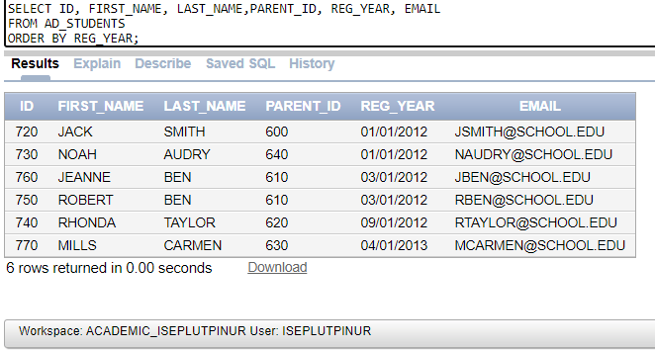

1. AD_EXAM_RESULTS ordered by STUDENT_ID and COURSE_ID

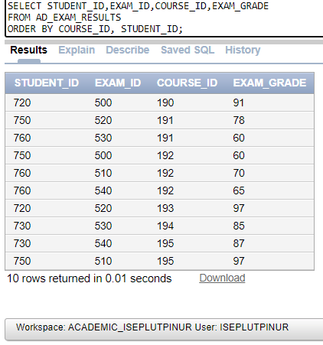

1. AD_STUDENT_ATTENDANCE ordered by STUDENT_ID

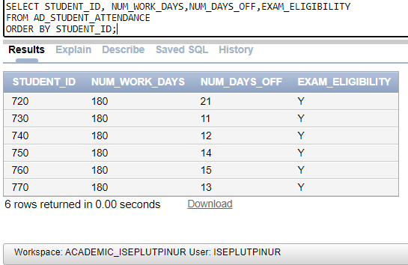

1. AD_DEPARTMENTS ordered by DEPT_ID

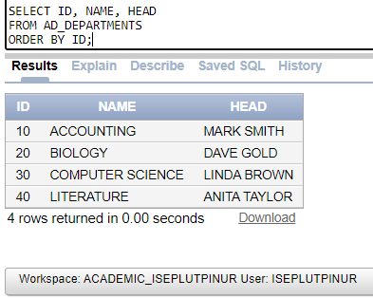

1. Display the percentage of days students have taken days off and sort the records based on the percentage calculated.

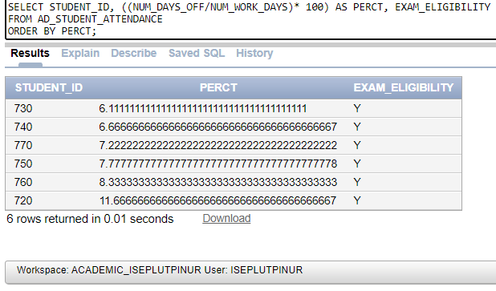

1. Display the top 5 students based on exam grade results.

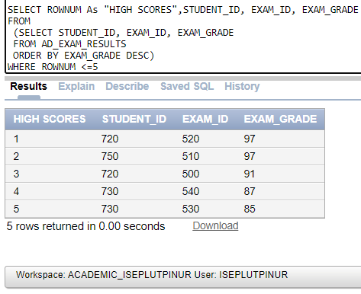

1. Display the parent details ordered by PARENT_ID.

